Reflective Memo

For this assignment, I chose to write out simple instructions on how to make a peanut butter and jelly sandwich. The audience for these instructions is those who are hungry, but don’t want to put forth the time or energy in prepping, cooking and cleaning up after a large meal. These instructions are detailed to where those who do not know how to make a PB&J can easily follow them and make the sandwich with ease.

When testing these instructions, I found that there were a few small details that I left out. For example, I didn’t include steps to closing the bread bag, peanut butter jar, and jelly jar. I also did not include a step to grab a plate for the sandwich to rest on. After going through my instructions, I made sure to include those simple steps and fully write out informative instructions that were simple and easy to follow.

I feel as if I achieved several course objectives that are listed on the syllabus. One of them is Organization, which is arranging content within their documents using appropriate patterns. For this assignment, I arranged the steps of how to make a PB&J sandwich in a clear and concise in chronological order. Another course objective that I achieved in this assignment is designing the document to the reader’s needs. I added pictures and clear instructions to fulfil the reader’s needs to have instructions on how to make a PB&J sandwich.

Introduction

Imagine this: you just got home from work, you’re starving but don’t want to put in all the effort of prepping, cooking and cleaning up a full meal. You want something fast, simple and easy to clean up. You peruse your pantry in hopes of finding something that fits the bill. You see it: a jar of peanut butter, jelly and a loaf of honey wheat bread looking absolutely delectable. But there is only one problem. It seems that (on an alternate universe where no one knows how to make a PB&J) that you have no idea how to make a PB&J. Lucky for you, you have step by step instructions, with pictures, of how to create this tasty meal.

**How to Make a Peanut Butter and Jelly Sandwich**

1. Find the peanut butter, jelly and loaf of bread in the pantry and place it on the counter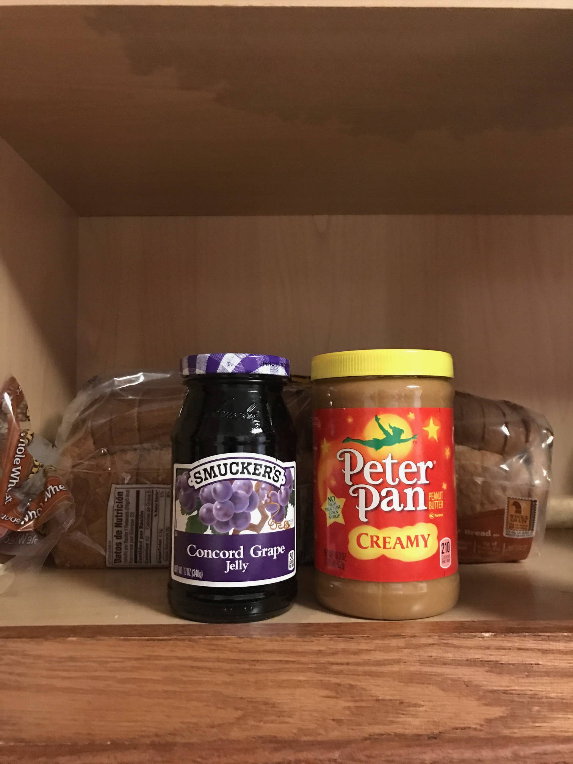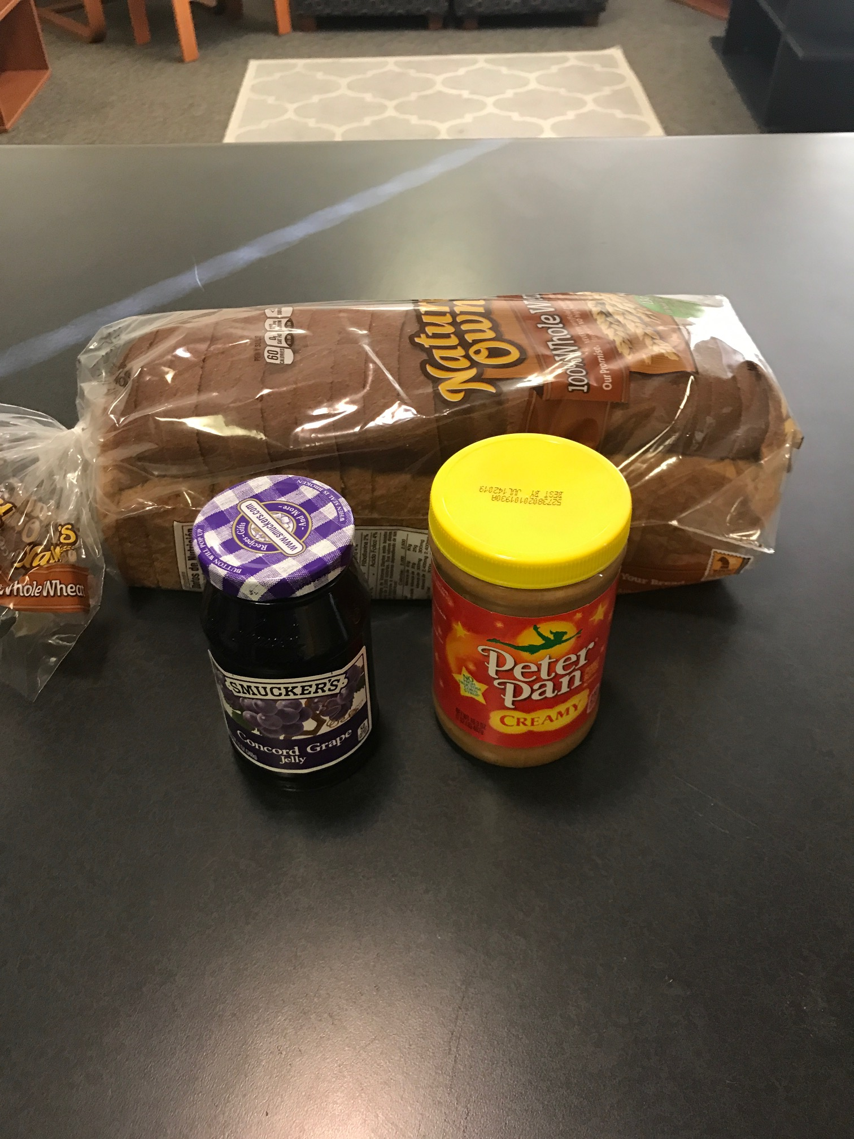
2. Grab a plate from the cabinet and place on the counter 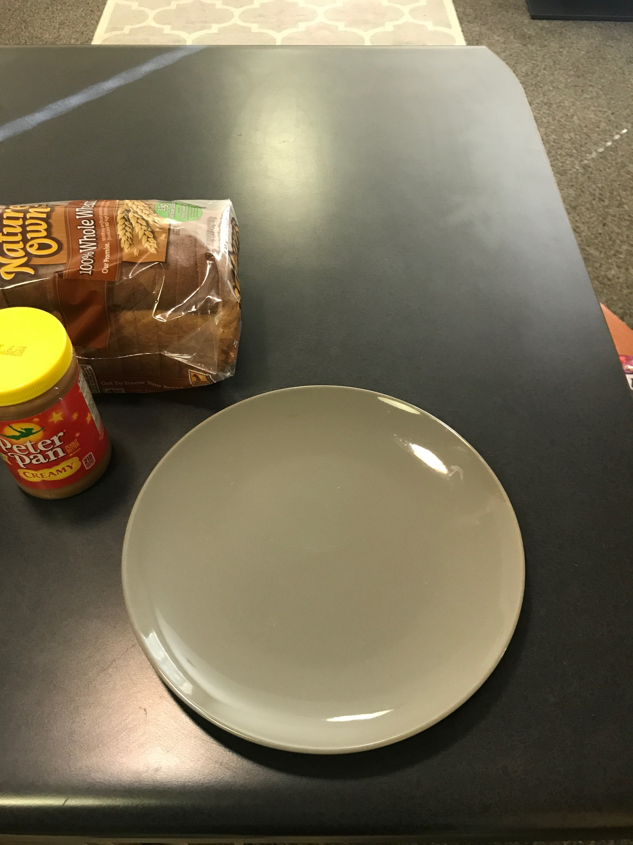
3. Grab a butter knife from the silverware drawer and place on the counter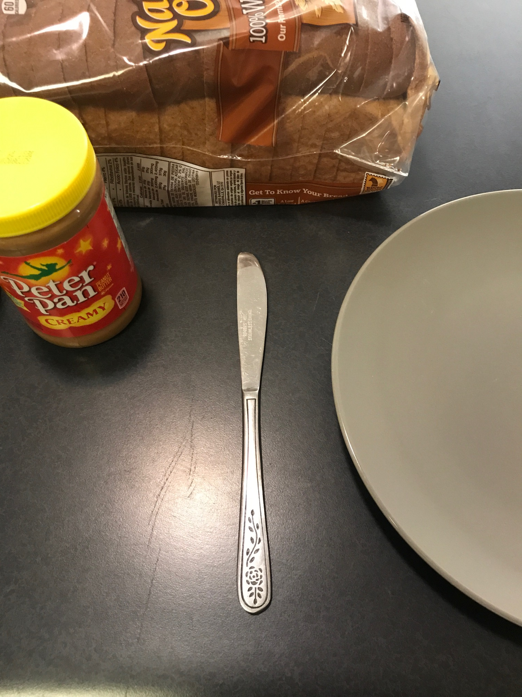
4. Open the bread loaf plastic bag and take out two pieces of bread (depending on your preference, the end or middle pieces are acceptable)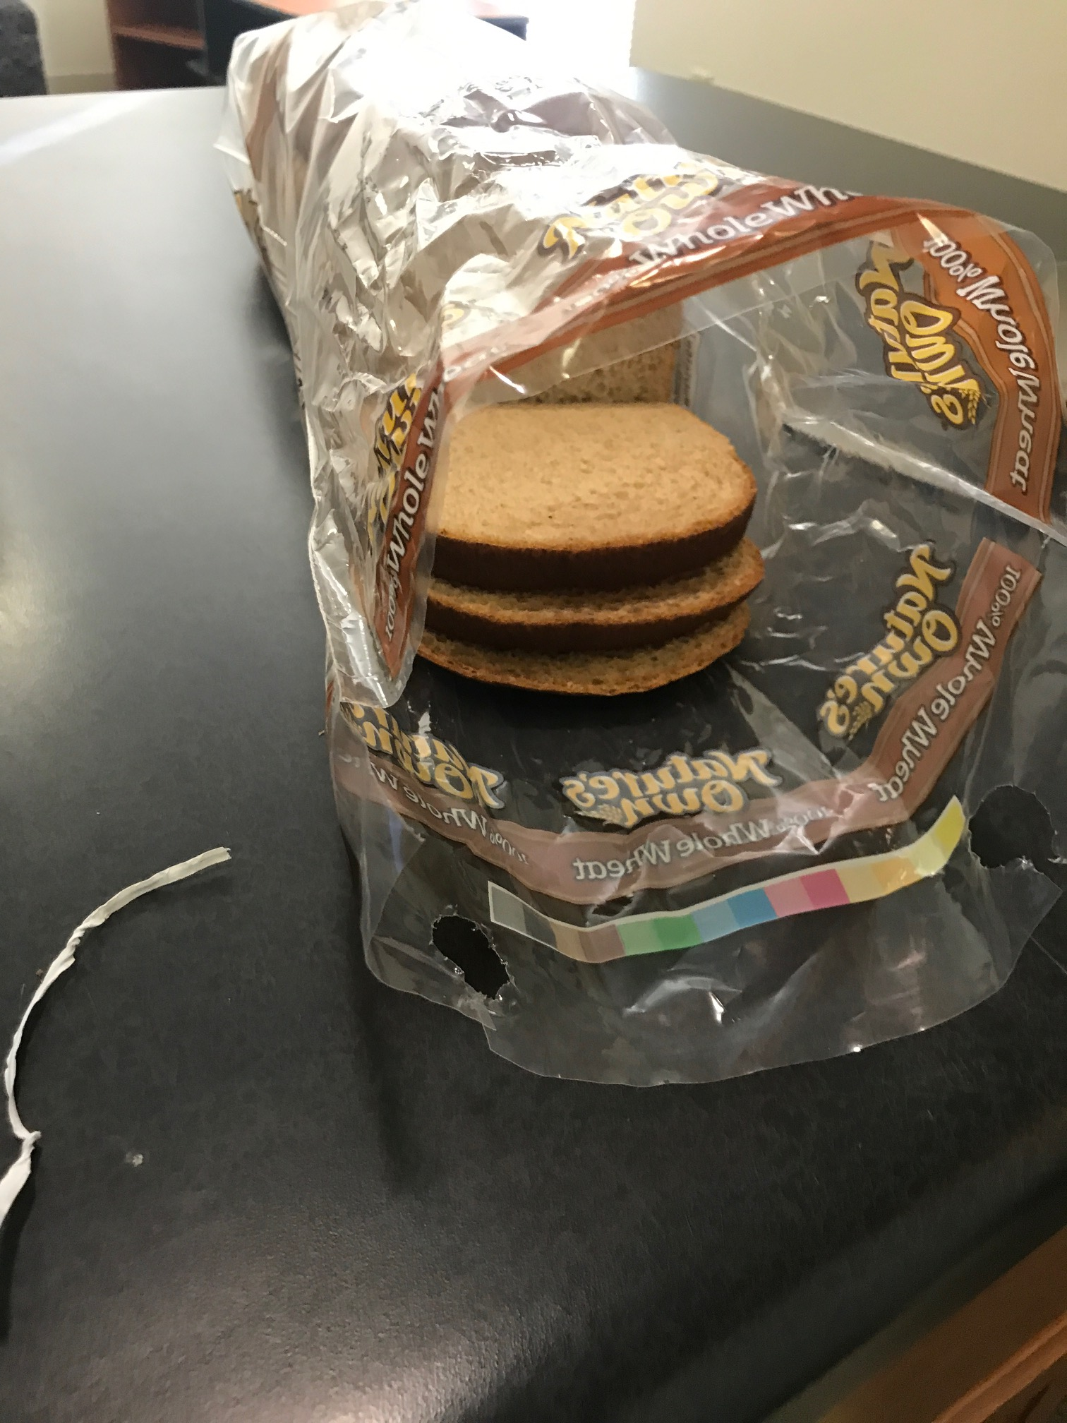
5. Place the bread slices on the plate

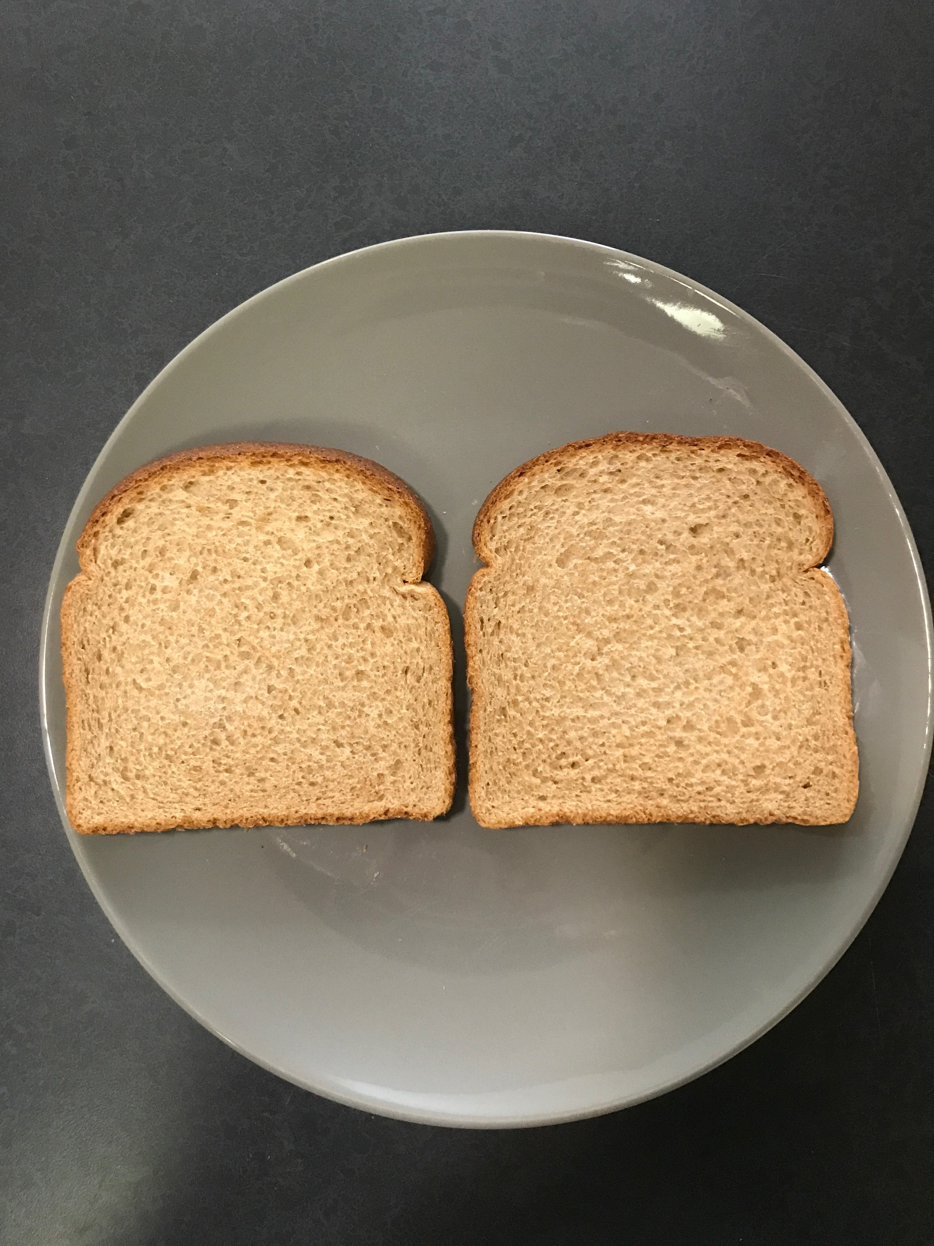

1. Close the bread loaf bag

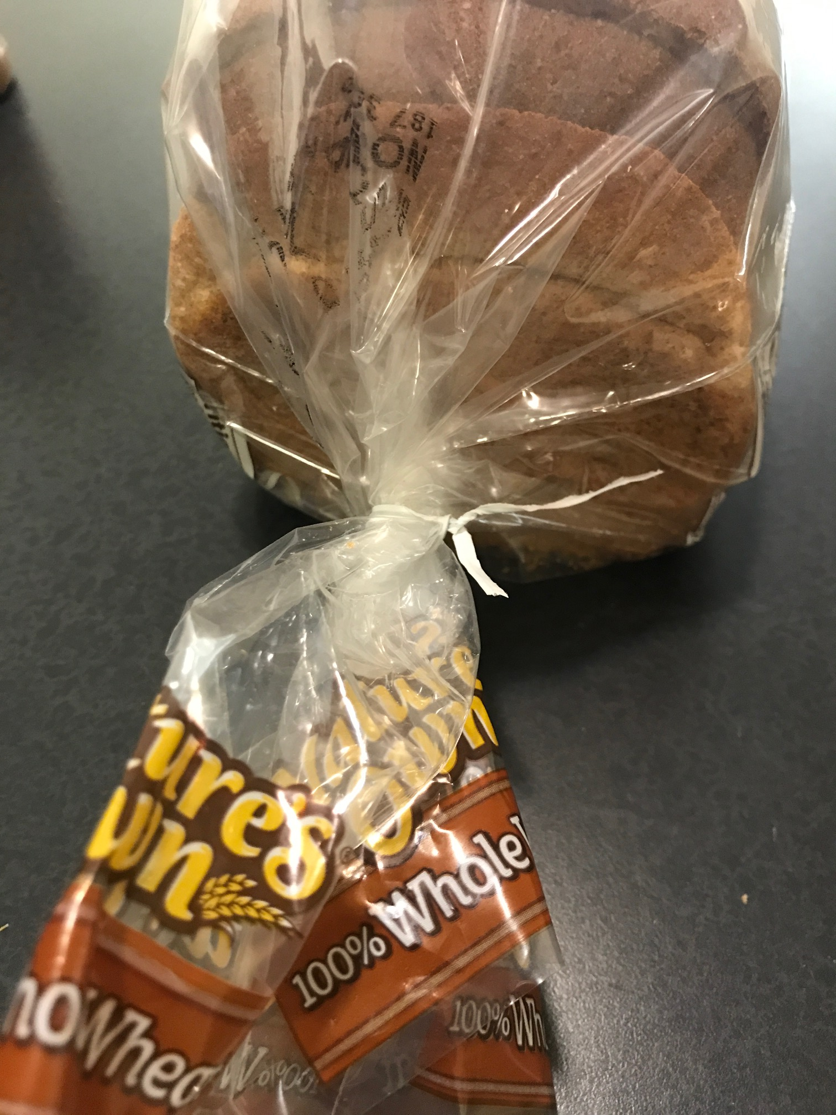

1. Open the peanut butter jar

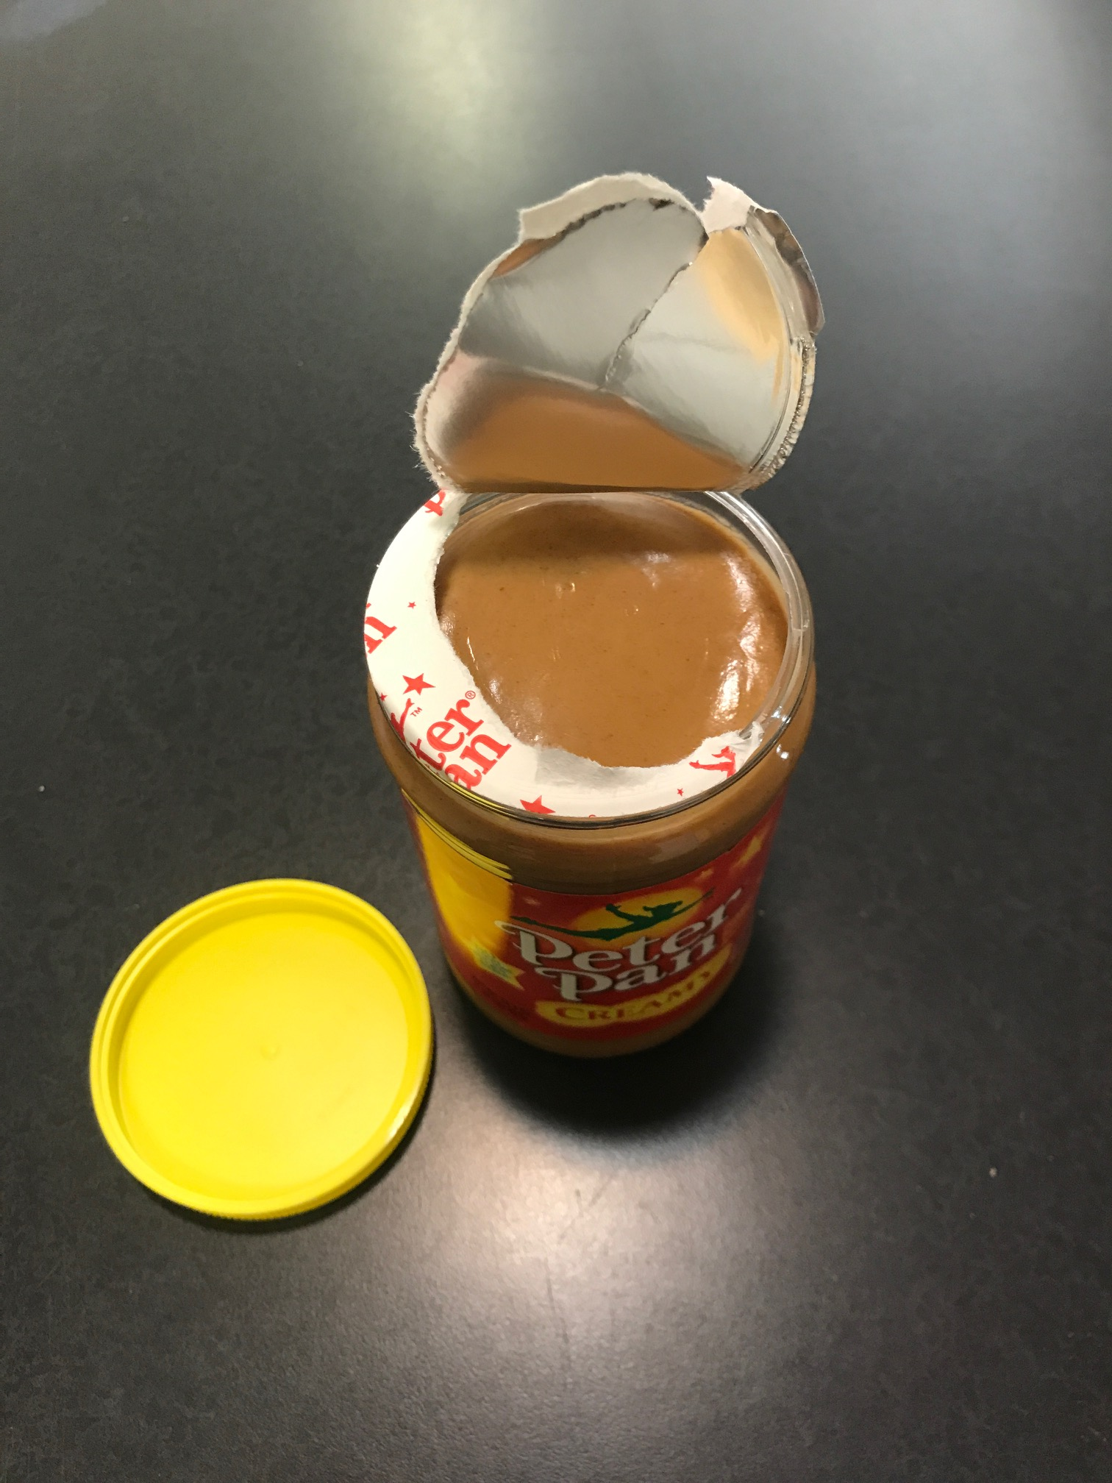

1. Scoop out a healthy amount of peanut butter with the knife (enough to spread onto one slice of bread)

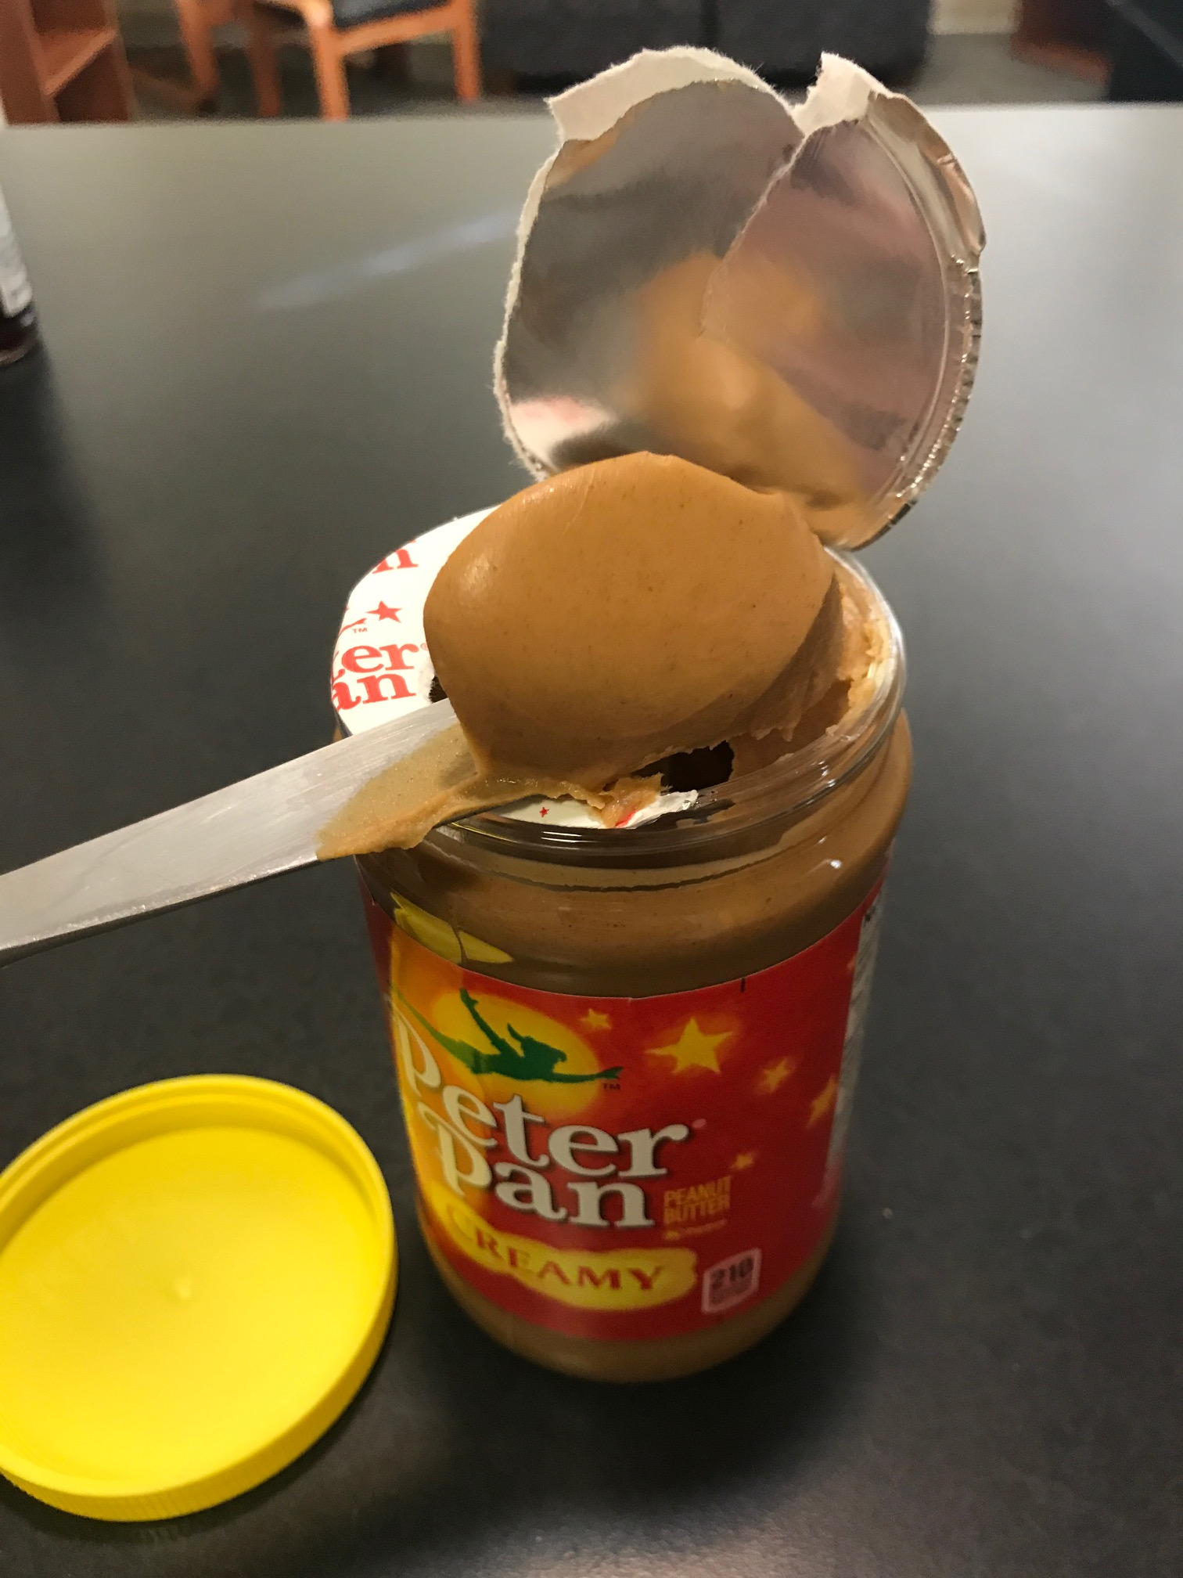

1. Spread that scoop evenly onto one side of a piece of bread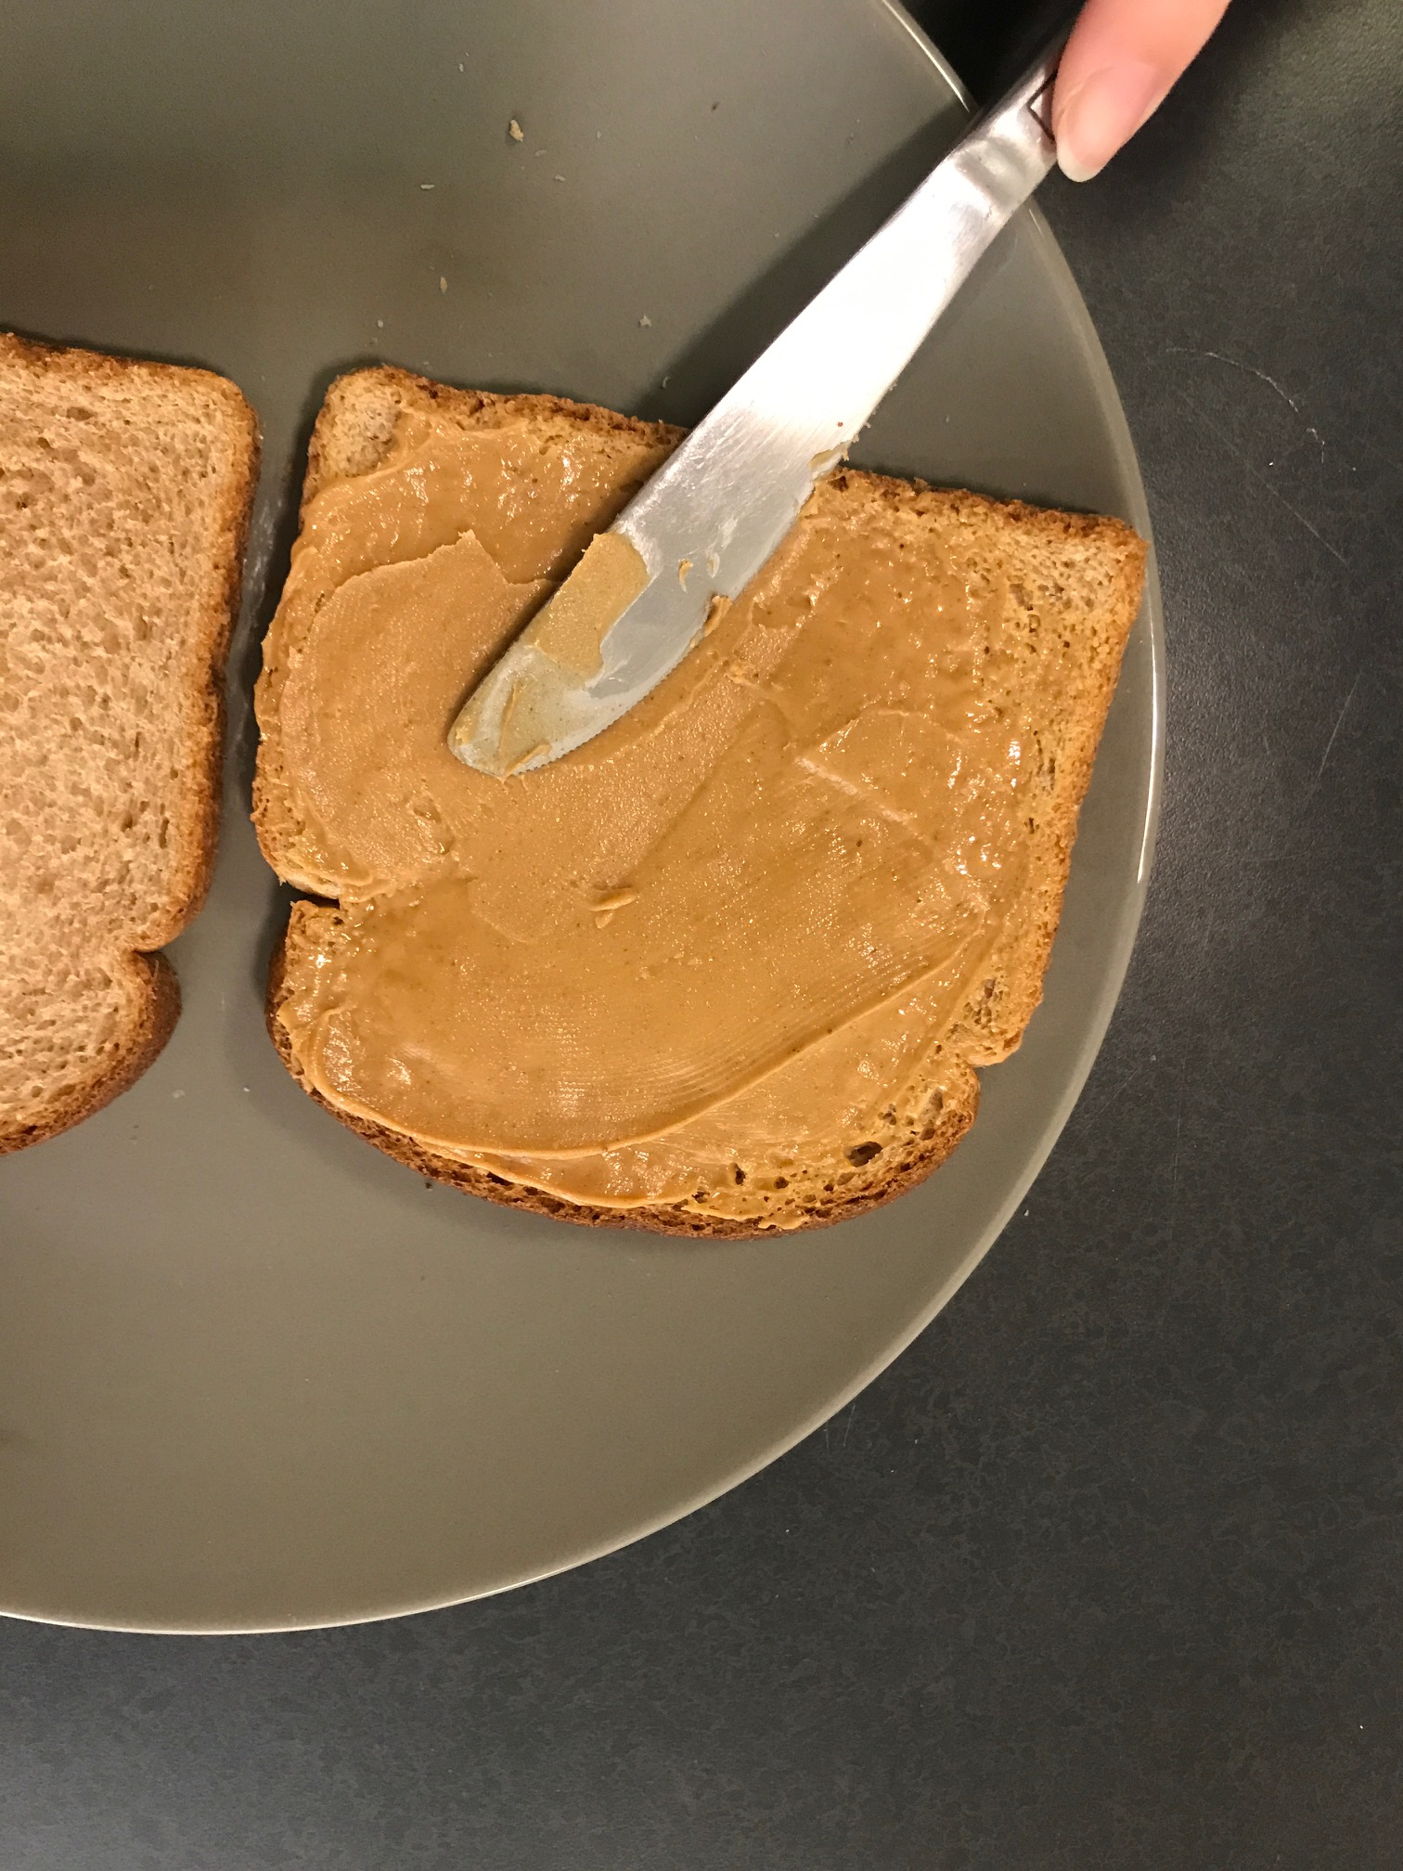
2. Close the peanut butter jar

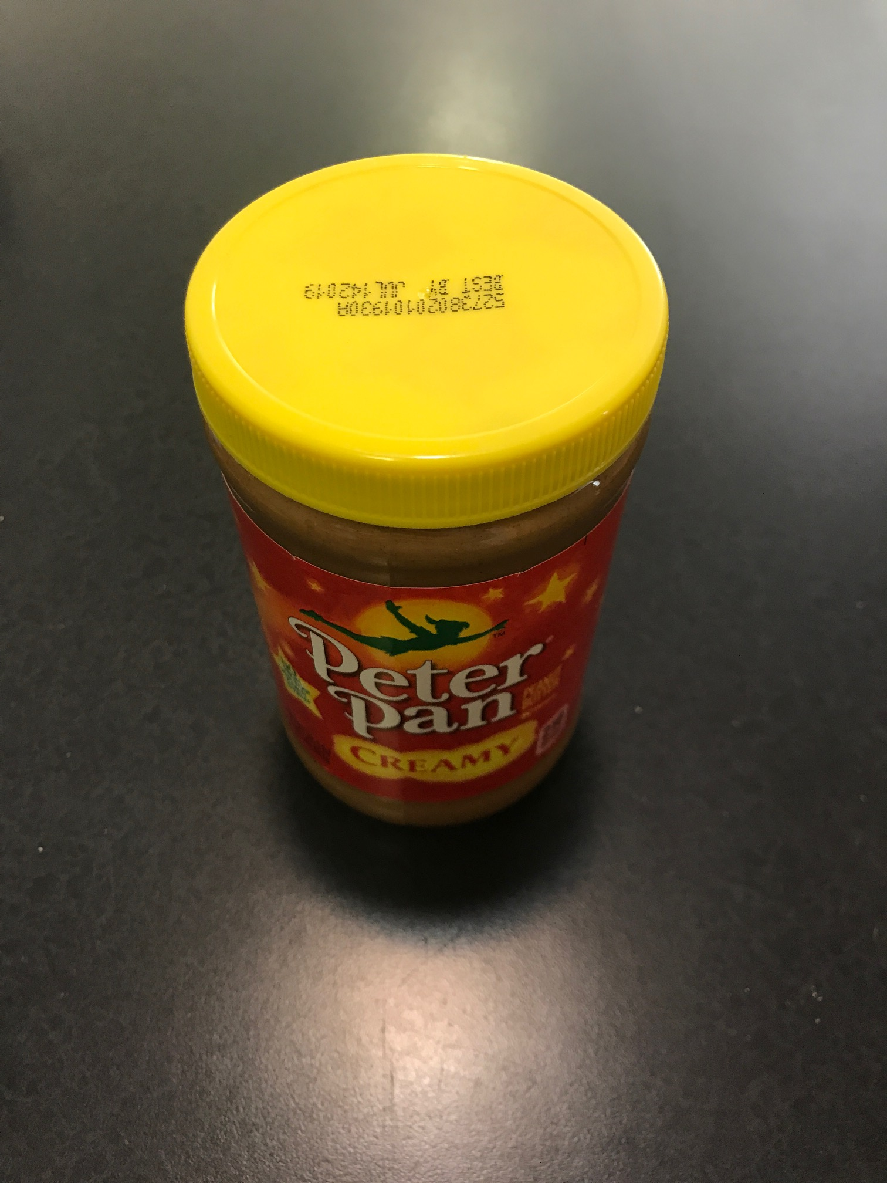

1. Clean the knife

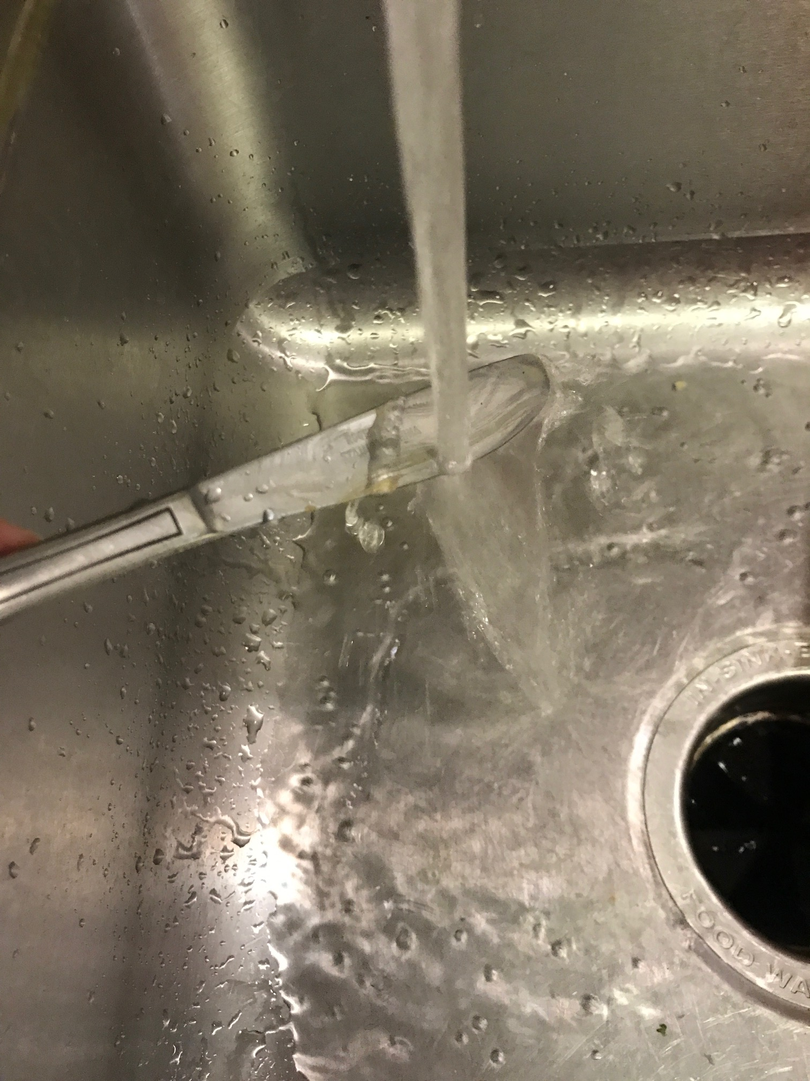

1. Open the jar of jelly

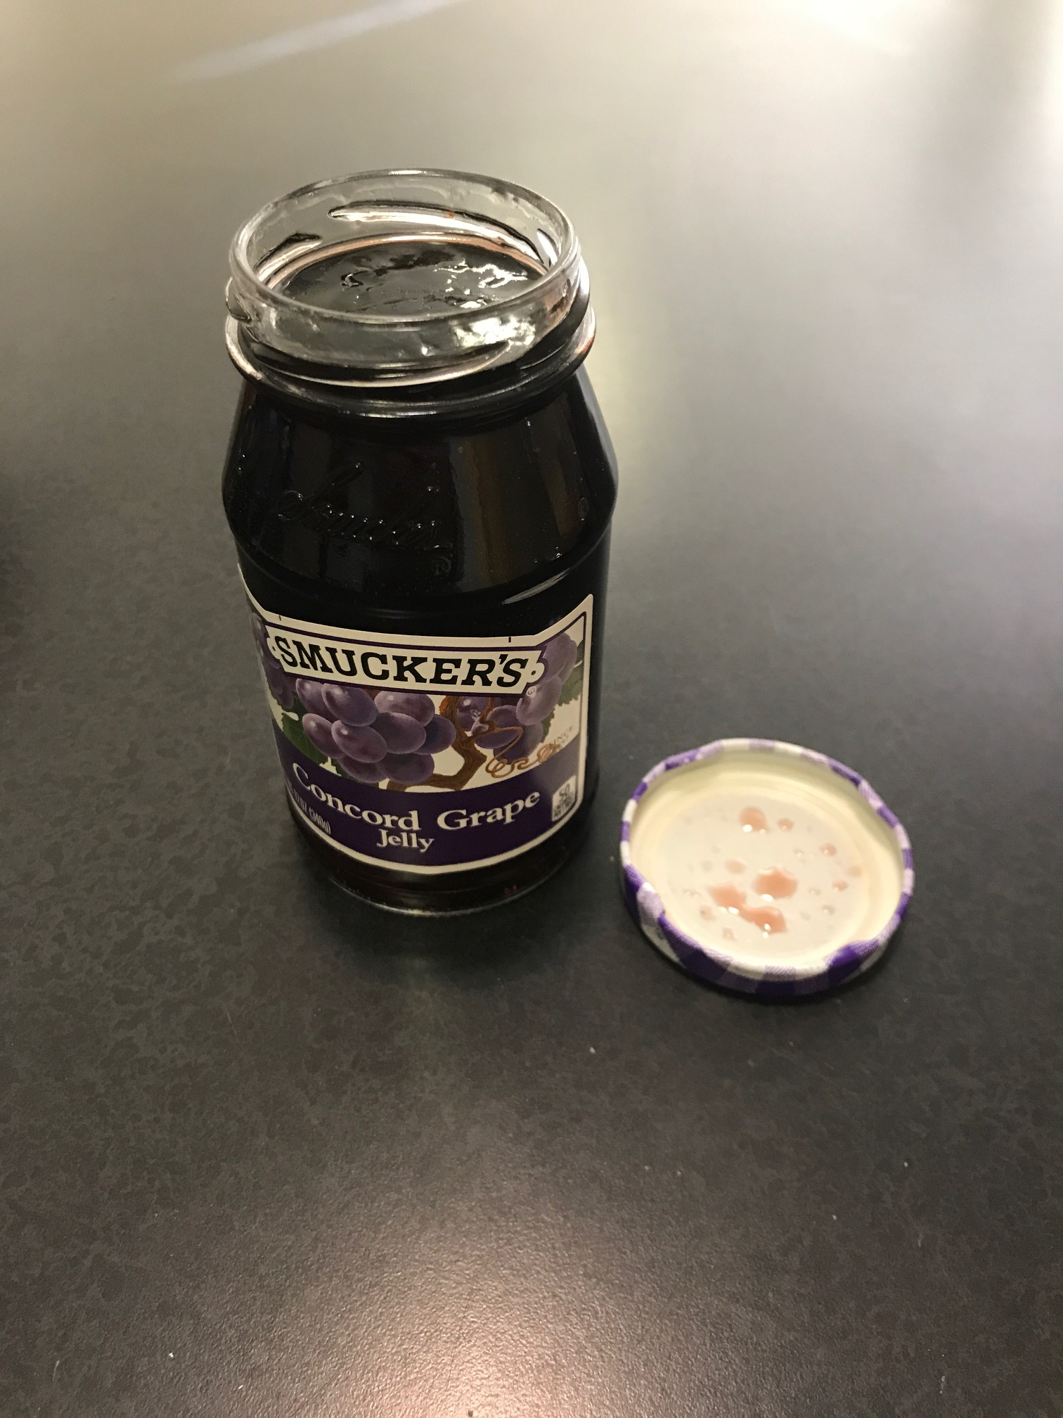

1. Scoop out the jelly with the knife onto one side of the other piece of bread (enough to spread onto one slice of bread) and spread it evenly across it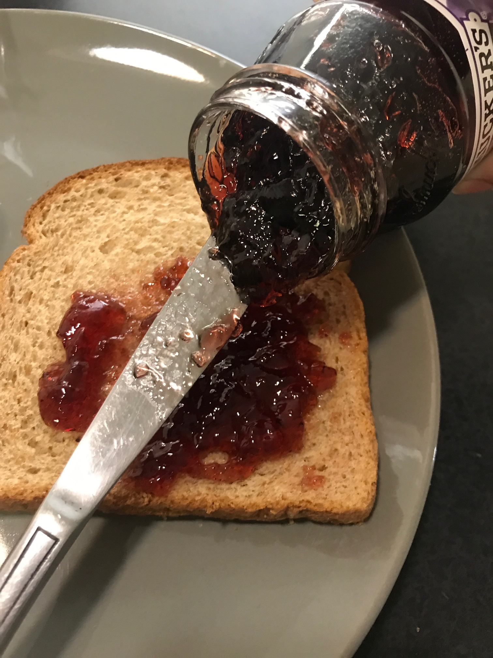
2. Close the jar of jelly

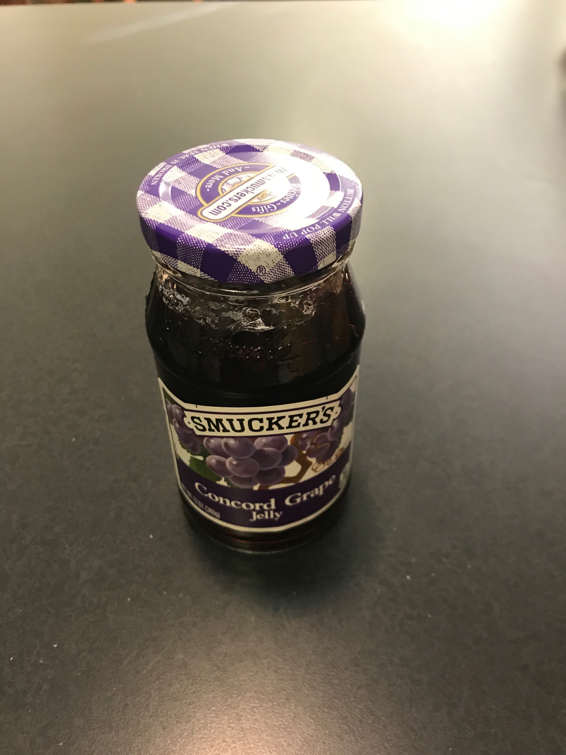

1. Place the knife into the sink or dishwasher (whichever one you use to wash your dishes)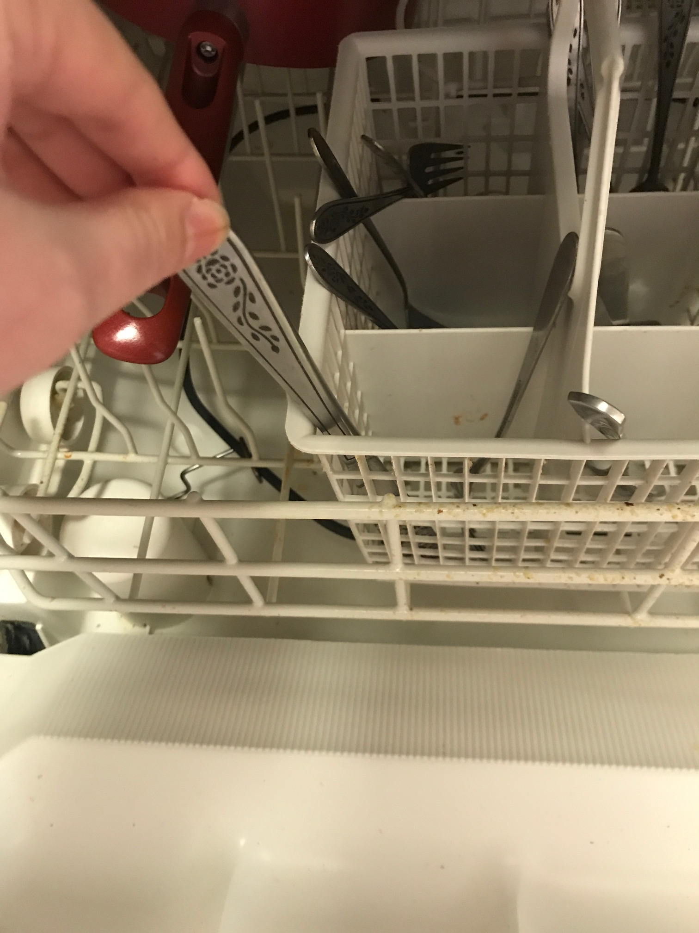
2. Pick up the other slice of bread and “sandwich” the two together, putting the peanut butter and jelly sides together

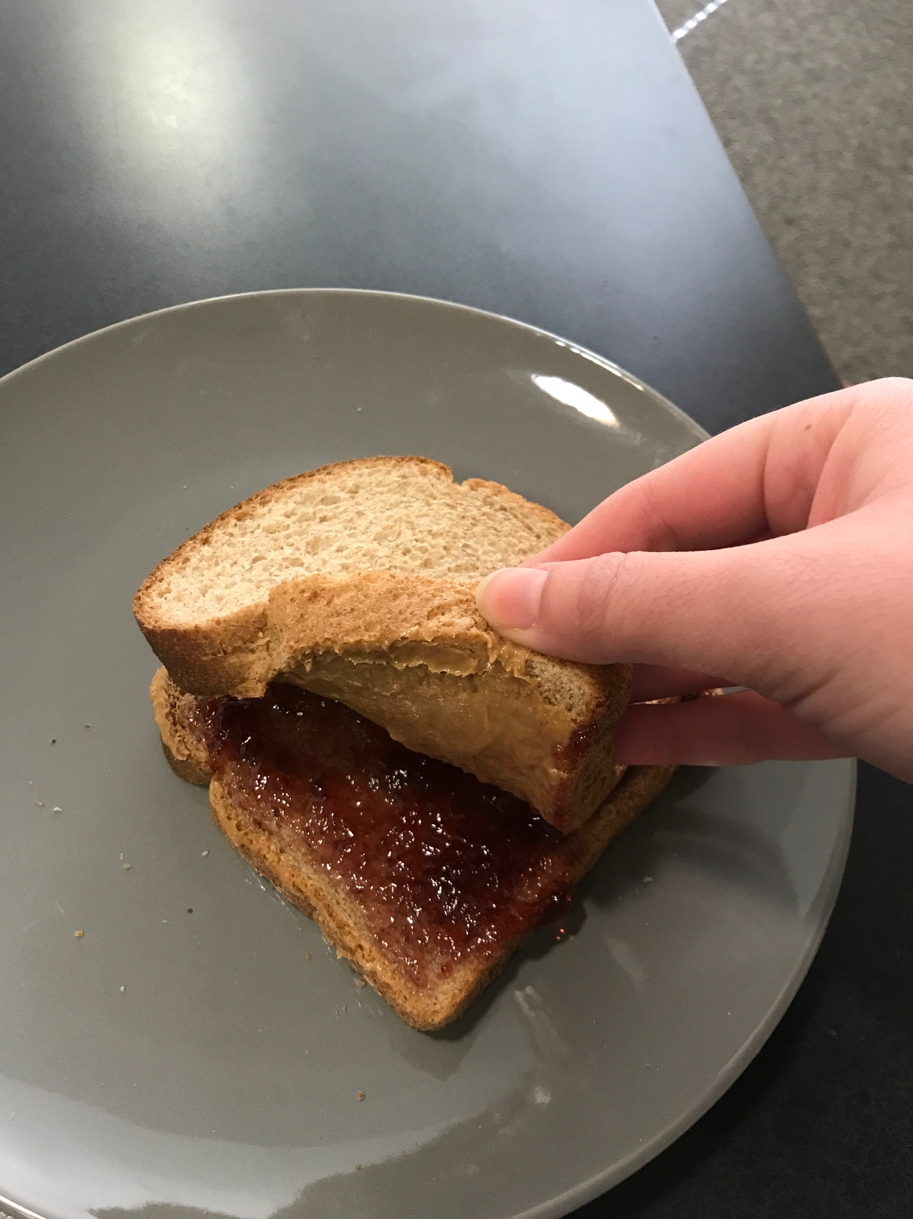

1. Eat the PB&J

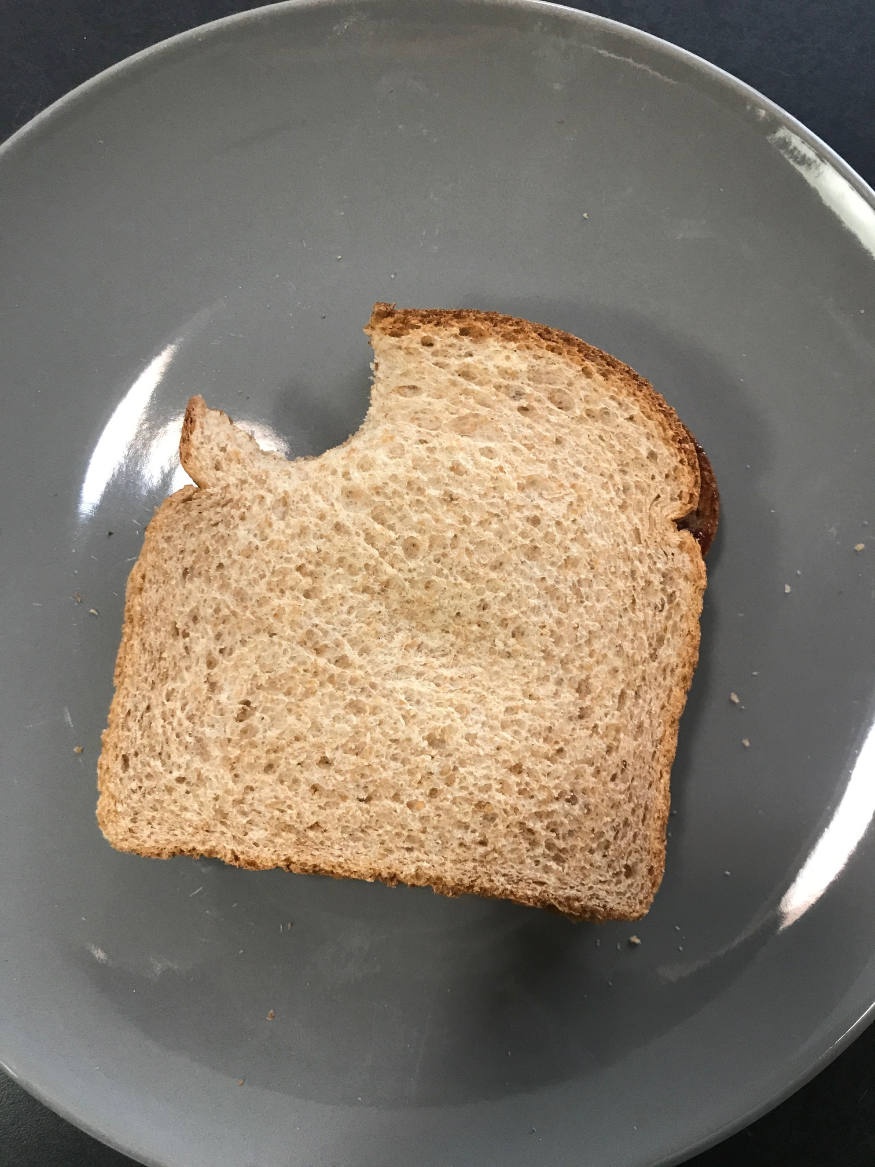

Conclusion

Now that you have a tasty meal that is fast, simple and easy to clean up, you can enjoy the rest of your evening, not having to worry or stress about prepping, cooking and cleaning up after a large meal. If need be, you can follow these instructions again and again (as long as you have the proper ingredients in stock) and enjoy this delicious meal.